e-GOS Registration Guide

Follow these steps to register for e-GOS.

  - In your web browser, go to https://nitaac.nih.gov/.
  - Click the “e-GOS Login” button
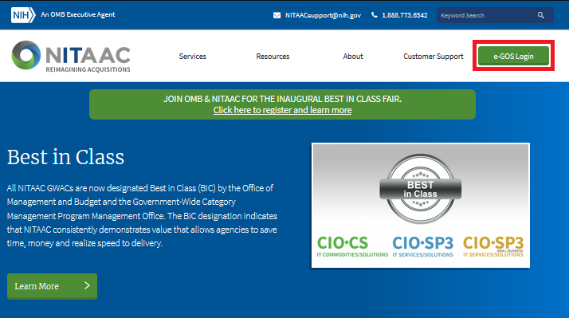
  - A pop-up will appear asking if you would like to continue, click “Continue to the above link”.
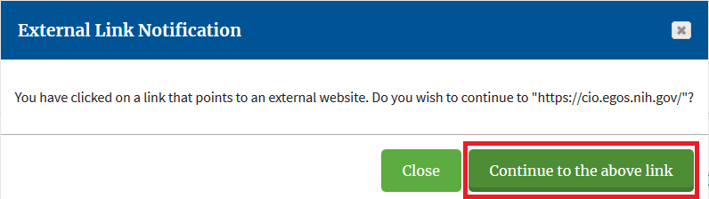

  - Type email address in the “New User” section then click “Register”.
Note: NIH employees must check the box labeled “Yes, I am an NIH Employee”
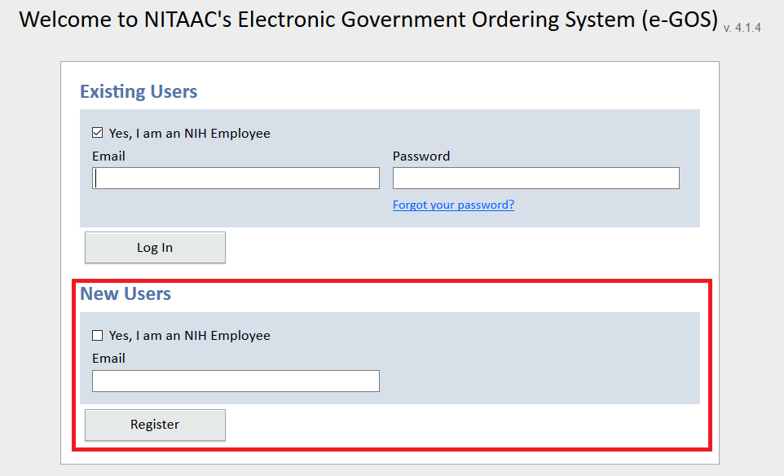
  - Enter your name and title, then select the appropriate department and agency from the dropdown.
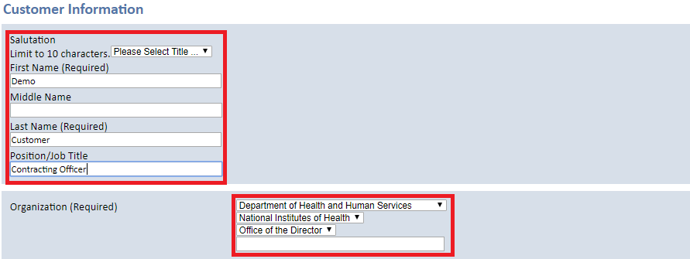

  - Fill in the address and contact information fields.
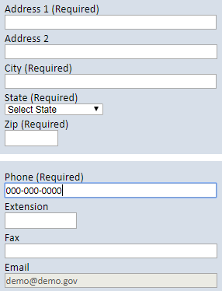
  - Create a password and secret question.
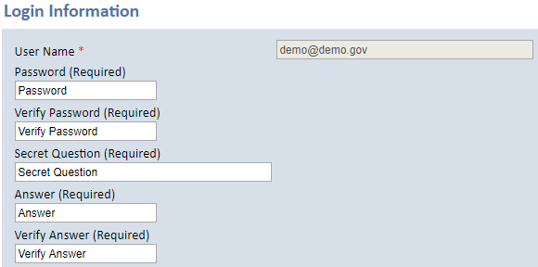

  - Read and agree to the rules of behavior.
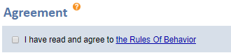
  - If you are a warranted contracting officer, check the box and click “Continue.”
Note: If you do not have a warrant, simply leave the box unchecked and click “Continue.”
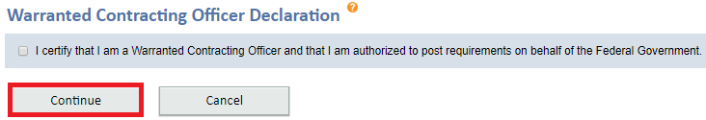

  - Review your information and then click “Confirm” to finalize your registration.
